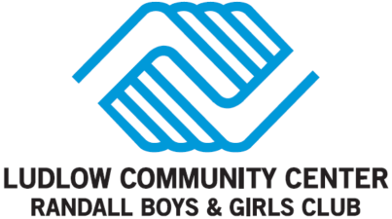
PARENT/GUARDIAN AGREEMENT FORM

PLEASE READ AND Sign Electronically:

____ I give The Randall Boys & Girls Club permission to photograph my child and for my child’s photo to be used in public relations materials, including local newspaper and social media.

____ In the case of emergency, I give The Randall Boys & Girls Club permission to take my child to the nearest medical emergency treatment facility and to authorize necessary treatment until I can be reached.

____ I understand that the Randall Boys & Girls Club may share information about my child with Boys & Girls Clubs of America (BGCA) for research purposes and/or to evaluate the program’s effectiveness. Data shared with BGCA will only include membership number and not name. Information that will be disclosed to BGCA may include the information provided on this application, information provided by your child’s school or school district, and other information collected by the Randall Boys & Girls Club, including data collected via surveys or questionnaires. All information provided to BGCA will be kept confidential.

____ I agree to not hold the Randall Boys & Girls Club responsible in the event of an injury resulting from activities in or related to the Club and its programs.

____ I am aware that participating in this Activity can be hazardous, I am aware of the dangers involved which may place my child at risk for possible injury, death, or damage to personal property, and I hereby agree to accept, on my behalf and on behalf of my heirs and assigns, any and all such risks. I also represent that my child’s participation in this Activity is entirely voluntary.

____ In exchange for the benefits derived by me from my child’s participation in this Activity, I hereby agree, to the fullest extent permitted by law, to release, indemnify, and hold harmless the Randall Boys & Girls Club, its officials, officers, employees, representatives, agents, or volunteers, from and against any claims, damages, or liability of any kind or nature for my child’s injury or death, or damage to my child’s personal property, arising out of or in connection with my child’s participation in this Activity, from whatever cause, including but not limited to the active or passive negligence of the Ludlow Community Center/Randall Boys & Girls Club, its officials, officers, employees, representatives, agents, servants, volunteers, or other Activity participants.

